♫ **Shake Break**

Do your students need a shake break? Check out the following YouTube video ***The Paw-Paw Patch*** (link: <https://www.youtube.com/watch?v=_C3RMTeb62I>) to get your students moving!

The Paw Paw Tree can be found all throughout the C&O Canal National Historical Park. Visitors from DC, Maryland, and West Virginia enjoy the Paw Paw fruit during the early summer season.

Enjoy a shake break and encourage your students to participate in imaginary play while picking the Paw Paw fruit from the Paw Paw patch.

**Paw Paw Fruit on Tree**

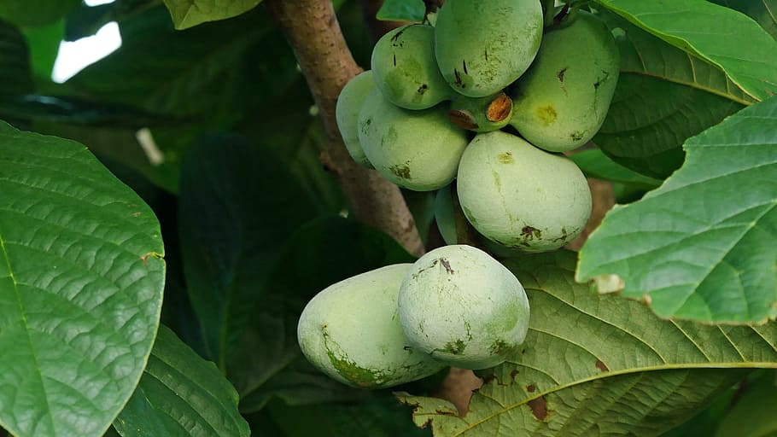

**Paw Paw Fruit and Seeds**All Paw Paw trees started off as seeds! Seeds are important to the start of a Paw Paw Patch.

